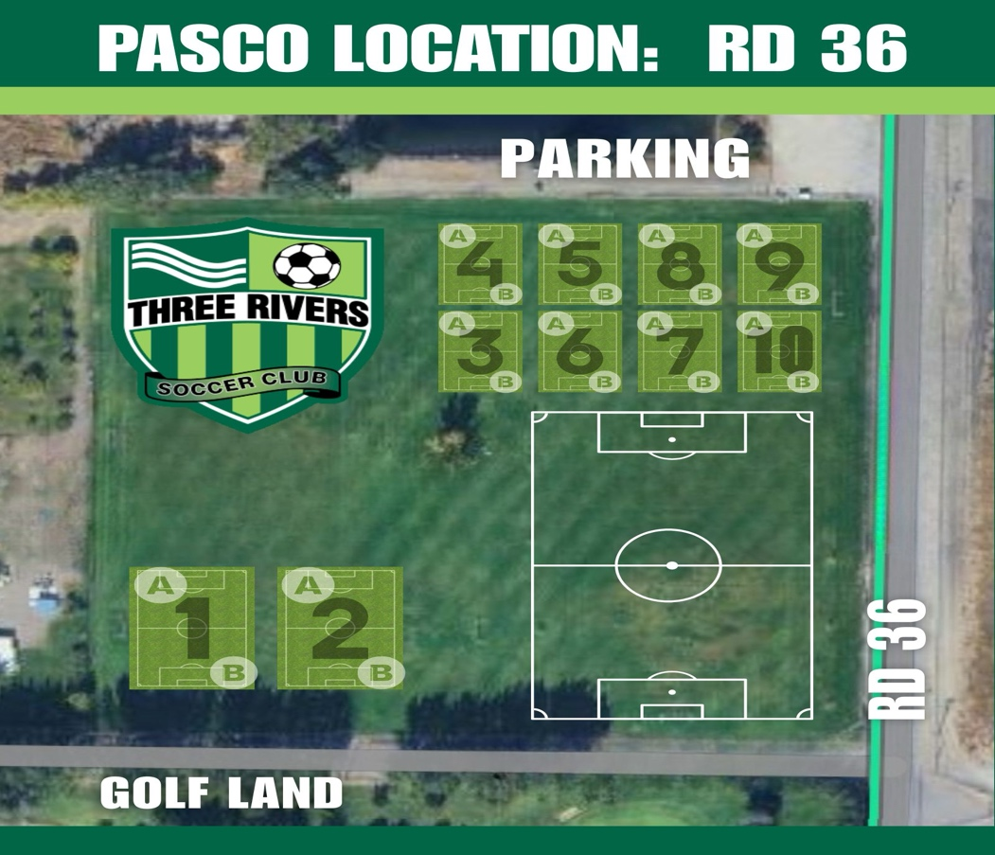

Practice Fields
Boys Girls
Team Name Field # Team Name |  |  | Field #
BU7 Kodiaks (Vanderboom) | 9A | GU7 Spartans (Bergquist) | 10A
BU7 Leeds (J. Ramos) | 9B | GU7 Dynamo (Cantu) | 10B
BU7 Reading (Lybert) | 8A | GU7 Wild (N. Garcia) | 7A
BU7 Silverbacks (J. Nelson) | 8B | GU7 Eagles (Jara) | 7B
BU8 AC Milan (Sophie CBC) | 5A | GU8 Arsenal (R. Boler) | 6A
BU8 Vikings (Katee & Azlyn CBC) | 5B | GU8 Courage (K. Walker) | 3A
BU8 Menace (Jose Cueva) | 4A | GU8 Man City (Morrissette) | 6B
 |  | GU8 Phoenix (K. Jensen) | 3B
 |  | GU8 Stars (M. Ramirez) | 4B

