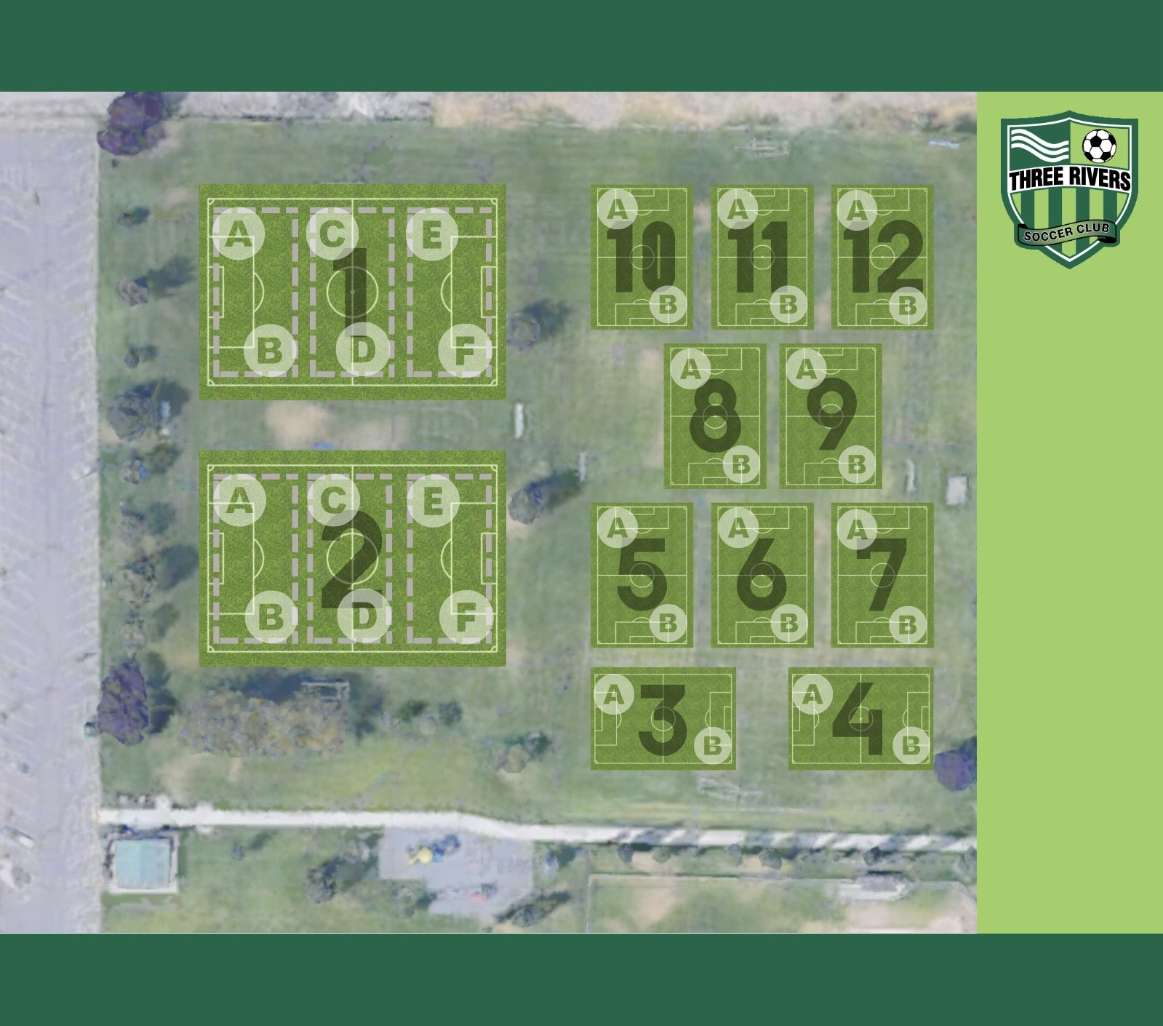

BOYS |  | Girls
Team Name | Field Number | Team Name | Field Number
BU7 Blizzard (T. Gibson) | 1A | 7 Jets (C. Johnson) | 9
BU7 Mavericks (N Howard) | 1B | GU7 Panthers (K. Dirkes) | 8B
BU7 Lightning (Corbin King) | 5A | GU7 Power (M. Smith) | 8A
BU7 Strikers (Onie King) | 5B | GU8 Fire (J. Braun) | 7
BU7 Storm (Abril CBC) | 1F | GU8 Hotspurs (A. Cruz) | 2E
BU8 Fireballs (Velicannin) | 10 | GU8 Man U (Craigo) | 2F
BU8 Force (Lopez) | 1E | GU8 Rangers (Wirth) | 6A
BU8 Smashers (Chloe Meiners) | 12A | GU8 Stingers (Sommerville) | 6B
BU8 Huskies (Josilyn Maddison) | 12B
BU8 Newcastle (Malagola) | 11A | GU9/10 Hurricanes | 13A
BU8 Sounders (Chunn) | 11B

