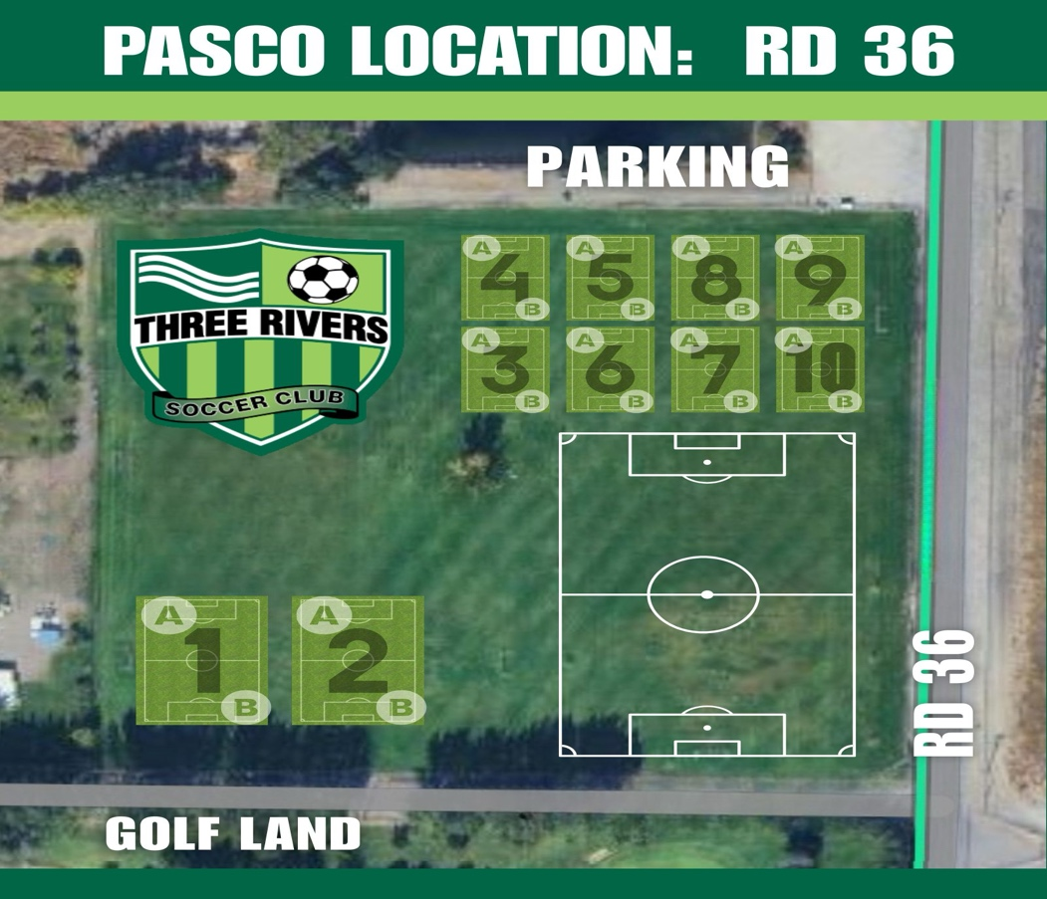

Boys Girls
Team Name Field # Team Name |  |  | Field #
BU5 Chivas (J. Magana/Navarro) | 9B | GU5 Advantage (A. Suarez) | 7
BU5 Cobras (J.Merrill) | 9A
BU6 Chargers (J. Cueva) | 8A | GU6 Fury (Lenihan) | 10A
BU6 Hawks (Darcy CBC) | 8B | GU6 Spirit (K. Walker) | 10B
BU6 Rebels (Hailee & Iva) | 5
BU8 Bengals (Alex Garza) | 6

