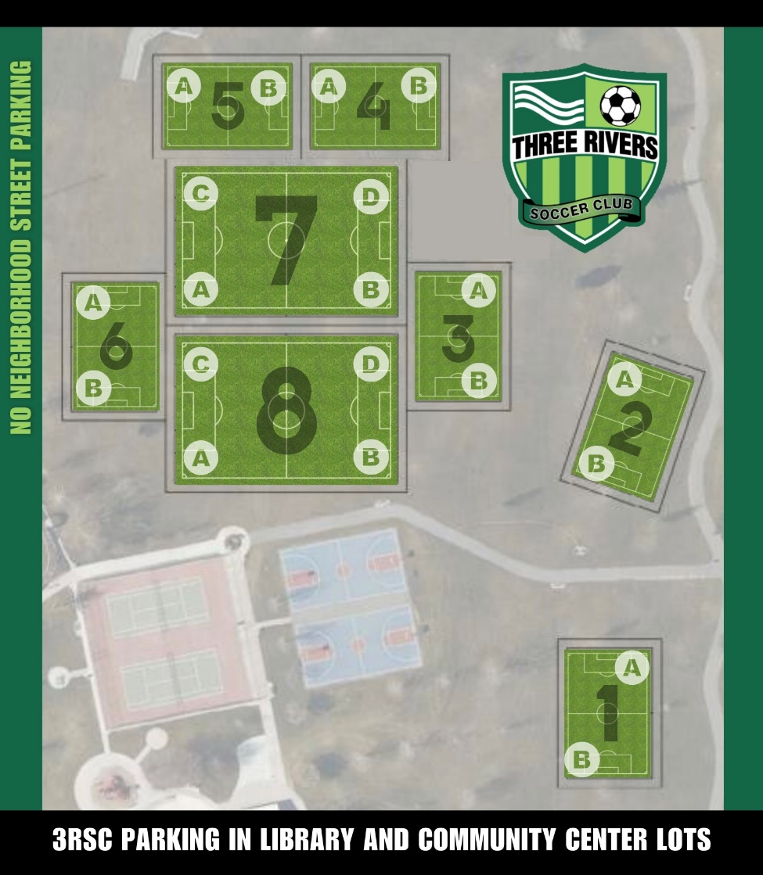

BOYS |  | GIRLS
TEAM | FIELD | TEAM | FIELD
BU05 Whitecaps (J. Ramirez) | 5A | GU5 Blaze (S Torres) | 6A
BU05 Tigers (Burt) | 5B | GU5 Wave (Espinoza) | 6B
BU06 Raiders (Midili) | 4A
BU06 Giants (Montelongo) | 4B | GU6 Jayhawks (Anika & Beth) | 7D
BU06 Lions (Lynette CBC) | 7C
BU9/10 BLUES (SMITH) | 8C

