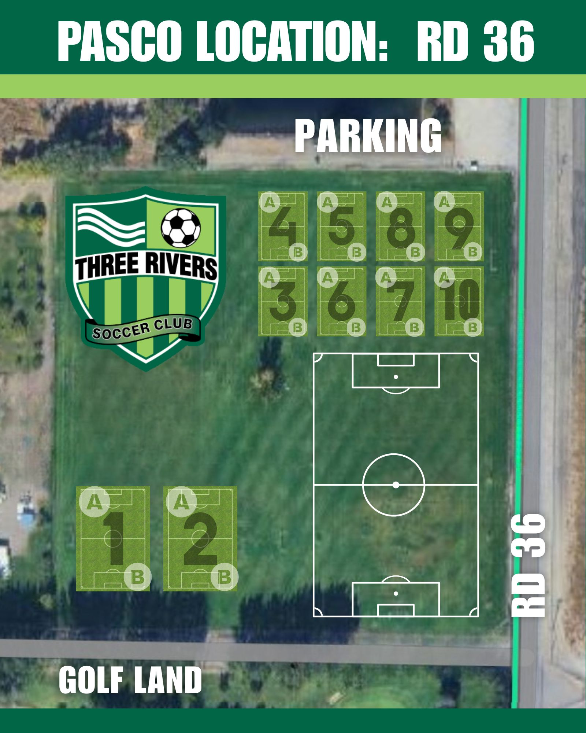

 | Week 1 Rotation
 | Boys Girls
 | Team Name Field # Team Name |  |  | Field #
 | BU9/10 Vipers (Olivera) | 1A | GU9/10 Aces (Harrer) | 2A
 | BU9/10 Broncos (Sam & Allie CBC) | 1B | GU9/10 Cyclones (Morrissette) | 2B
 | BU9/10 Badgers (Bergquist) | 5 | GU9/10 Vandals (Mitchell) | 6
 | BU9/10 Wolves (Garibay) | 4 | GU9/10 Xtreme (J. Ramos) | 3
Week 2 Rotation
Boys Girls
Team Name Field # Team Name |  |  |  | Field #
BU9/10 Vipers (Olivera) |  | 5 | GU9/10 Aces (Harrer) | 6
BU9/10 Broncos (Sam & Allie CBC) |  | 4 | GU9/10 Cyclones (Morrissette) | 3
BU9/10 Badgers (Bergquist) |  | 1A | GU9/10 Vandals (Mitchell) | 2B
BU9/10 Wolves (Garibay) |  | 1B | GU9/10 Xtreme (J. Ramos) | 2A
Week 3 Rotation
Boys Girls
Team Name Field # Team Name |  |  |  | Field #
BU9/10 Vipers (Olivera) |  | 1A | GU9/10 Aces (Harrer) | 2A
BU9/10 Broncos (Sam & Allie CBC) |  | 1B | GU9/10 Cyclones (Morrissette) | 2B
BU9/10 Badgers (Bergquist) |  | 5 | GU9/10 Vandals (Mitchell) | 6
BU9/10 Wolves (Garibay) |  | 4 | GU9/10 Xtreme (J. Ramos) | 3

Week 4 Rotation
Boys Girls
Team Name Field # Team Name |  |  |  |  | Field #
BU9/10 Vipers (Olivera) | 5 |  | GU9/10 Aces (Harrer) |  | 6
BU9/10 Broncos (Sam & Allie CBC) | 4 |  | GU9/10 Cyclones (Morrissette) |  | 3
BU9/10 Badgers (Bergquist) | 1A |  | GU9/10 Vandals (Mitchell) |  | 2B
BU9/10 Wolves (Garibay) | 1B |  | GU9/10 Xtreme (J. Ramos) |  | 2A
Week 5 Rotation
Boys Girls
Team Name Field # Team Name |  |  |  |  |  | Field #
BU9/10 Vipers (Olivera) |  | 1A |  | GU9/10 Aces (Harrer) |  | 2A
BU9/10 Broncos (Sam & Allie CBC) |  | 1B |  | GU9/10 Cyclones (Morrissette) |  | 2B
BU9/10 Badgers (Bergquist) |  | 5 |  | GU9/10 Vandals (Mitchell) |  | 6
BU9/10 Wolves (Garibay) |  | 4 |  | GU9/10 Xtreme (J. Ramos) |  | 3
Week 6 Rotation
Boys Girls
Team Name Field # Team Name |  |  |  |  |  | Field #
BU9/10 Vipers (Olivera) |  | 5 |  | GU9/10 Aces (Harrer) |  | 6
BU9/10 Broncos (Sam & Allie CBC) |  | 4 |  | GU9/10 Cyclones (Morrissette) |  | 3
BU9/10 Badgers (Bergquist) |  | 1A |  | GU9/10 Vandals (Mitchell) |  | 2B
BU9/10 Wolves (Garibay) |  | 1B |  | GU9/10 Xtreme (J. Ramos) |  | 2A

