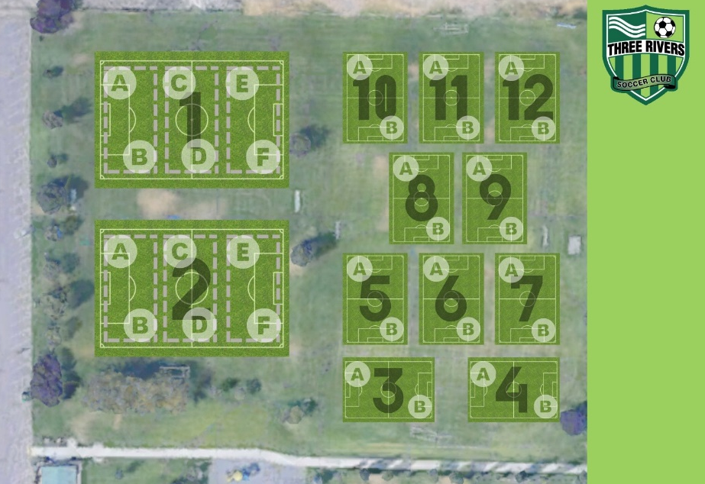
Field 13

 | Week 1 Rotation
 | Boys Girls
 | Team Name Field # Team Name |  |  | Field #
 | BU9/10 Galaxy (Grob) | 1A | GU9/10 Hawkeyes – (Waterland) | 2A
 | BU9/10 Hornets (McGilliard) | 1F | GU9/10 Saints – (Chunn) | 2B
 | BU9/10 Cougars – (Leigh) | 10 | GU9/10 Wildcats (S. Miller) | 8
 | BU9/10 United (Welch) | 11
 | BU9/10 Bobcats (Lopez) | 13A
 | BU9/10 Attack (Kendall/Brooklyn) | 13F
Week 2 Rotation
Boys Girls
Team Name Field # Team Name |  |  |  | Field #
BU9/10 Galaxy (Grob) |  | 10 | GU9/10 Hawkeyes – (Waterland) | 2A
BU9/10 Hornets (McGilliard) |  | 11 | GU9/10 Saints – (Chunn) | 2B
BU9/10 Cougars – (Leigh) |  | 1A | GU9/10 Wildcats (S. Miller) | 13A
BU9/10 United (Welch) |  | 1F
BU9/10 Bobcats (Lopez) |  | 5
BU9/10 Attack (Kendall/Brooklyn) |  | 6
Week 3 Rotation
Boys Girls
Team Name Field # Team Name |  |  |  | Field #
BU9/10 Galaxy (Grob) |  | 1A | GU9/10 Hawkeyes – (Waterland) | 8
BU9/10 Hornets (McGilliard) |  | 1F | GU9/10 Saints – (Chunn) | 2B
BU9/10 Cougars – (Leigh) |  | 13A | GU9/10 Wildcats (S. Miller) | 2A
BU9/10 United (Welch) |  | 13F
BU9/10 Bobcats (Lopez) |  | 5
BU9/10 Attack (Kendall/Brooklyn) |  | 6

Week 4 Rotation
Boys Girls
Team Name Field # Team Name |  |  |  |  | Field #
BU9/10 Galaxy (Grob) | 10 |  | GU9/10 Hawkeyes – (Waterland) |  | 2A
BU9/10 Hornets (McGilliard) | 11 |  | GU9/10 Saints – (Chunn) |  | 2B
BU9/10 Cougars – (Leigh) | 5 |  | GU9/10 Wildcats (S. Miller) |  | 13A
BU9/10 United (Welch) | 6
BU9/10 Bobcats (Lopez) | 1A
BU9/10 Attack (Kendall/Brooklyn) | 1F
Week 5 Rotation
Boys Girls
Team Name Field # Team Name |  |  |  |  |  | Field #
BU9/10 Galaxy (Grob) |  | 10 |  | GU9/10 Hawkeyes – (Waterland) |  | 2A
BU9/10 Hornets (McGilliard) |  | 11 |  | GU9/10 Saints – (Chunn) |  | 2B
BU9/10 Cougars – (Leigh) |  | 1A |  | GU9/10 Wildcats (S. Miller) |  | 8
BU9/10 United (Welch) |  | 1F
BU9/10 Bobcats (Lopez) |  | 13A
BU9/10 Attack (Kendall/Brooklyn) |  | 13F
Week 6 Rotation
Boys Girls
Team Name Field # Team Name |  |  |  |  |  | Field #
BU9/10 Galaxy (Grob) |  | 1A |  | GU9/10 Hawkeyes – (Waterland) |  | 13F
BU9/10 Hornets (McGilliard) |  | 1F |  | GU9/10 Saints – (Chunn) |  | 2A
BU9/10 Cougars – (Leigh) |  | 10 |  | GU9/10 Wildcats (S. Miller) |  | 2B
BU9/10 United (Welch) |  | 11
BU9/10 Bobcats (Lopez) |  | 5
BU9/10 Attack (Kendall/Brooklyn) |  | 6

