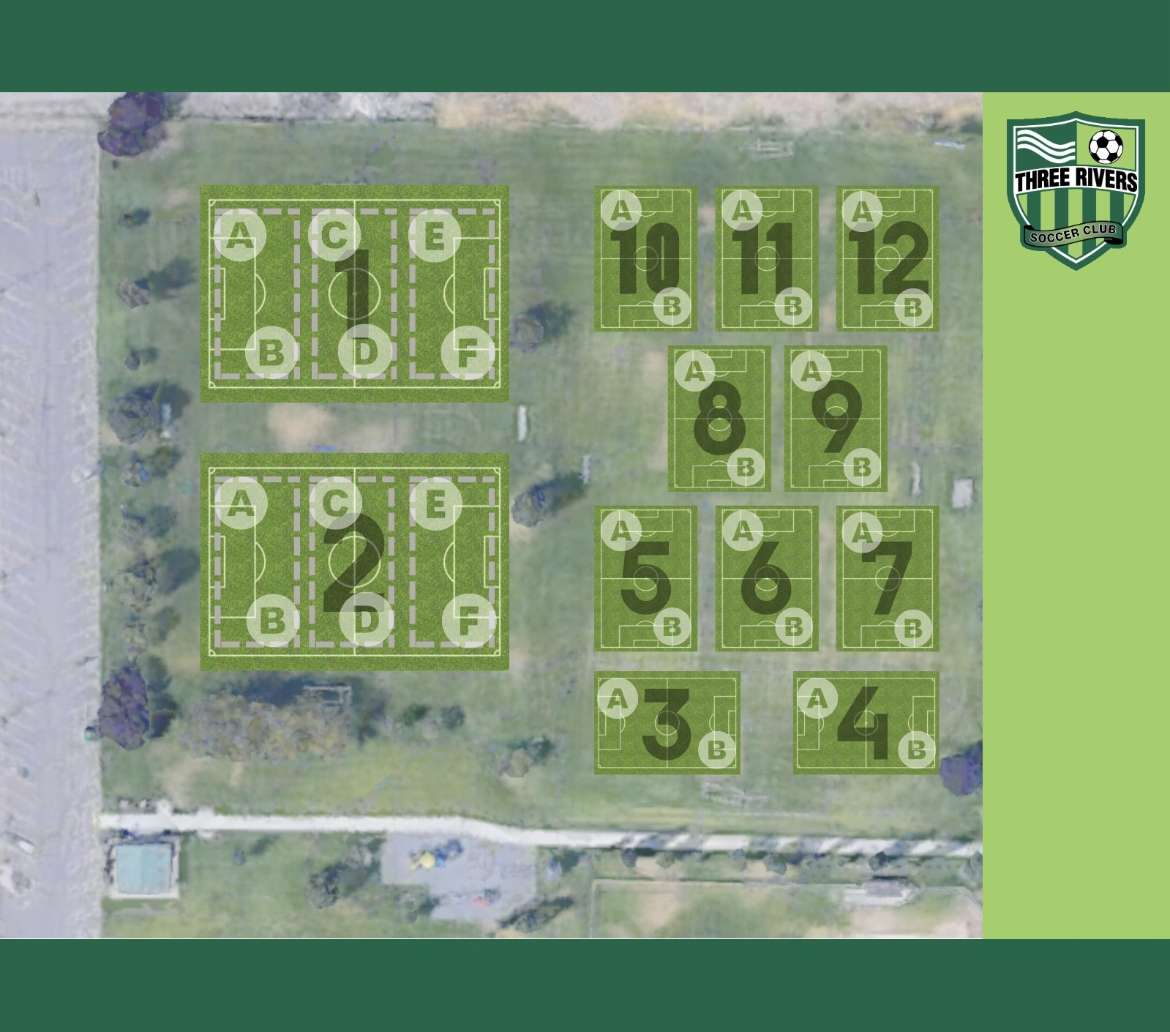

BOYS |  | Girls
Team Name | Field Number | Team Name | Field Number
BU5 Red Jets (Asmussen) | 8A | GU5 Cheetahs (Greenough) | 6A
BU5 Shadow (A. Cruz) | 8B | GU5 Cubs (Hjellum) | 6B
BU6 Blades (Howard) | 10A | GU6 Bolton (Lucatero) | 9B
BU6 Rockets (McCoy) | 10B | GU6 Dash (Henry) | 9A
BU6 Thunderbirds (Malagola) | 11A | GU6 Legends (N. Wood) | 7B
BU6 Gladiators (Gomez) | 11B | GU5 Pumas (Burch) | 7A
BU5 Bears (Hester) | 12B

