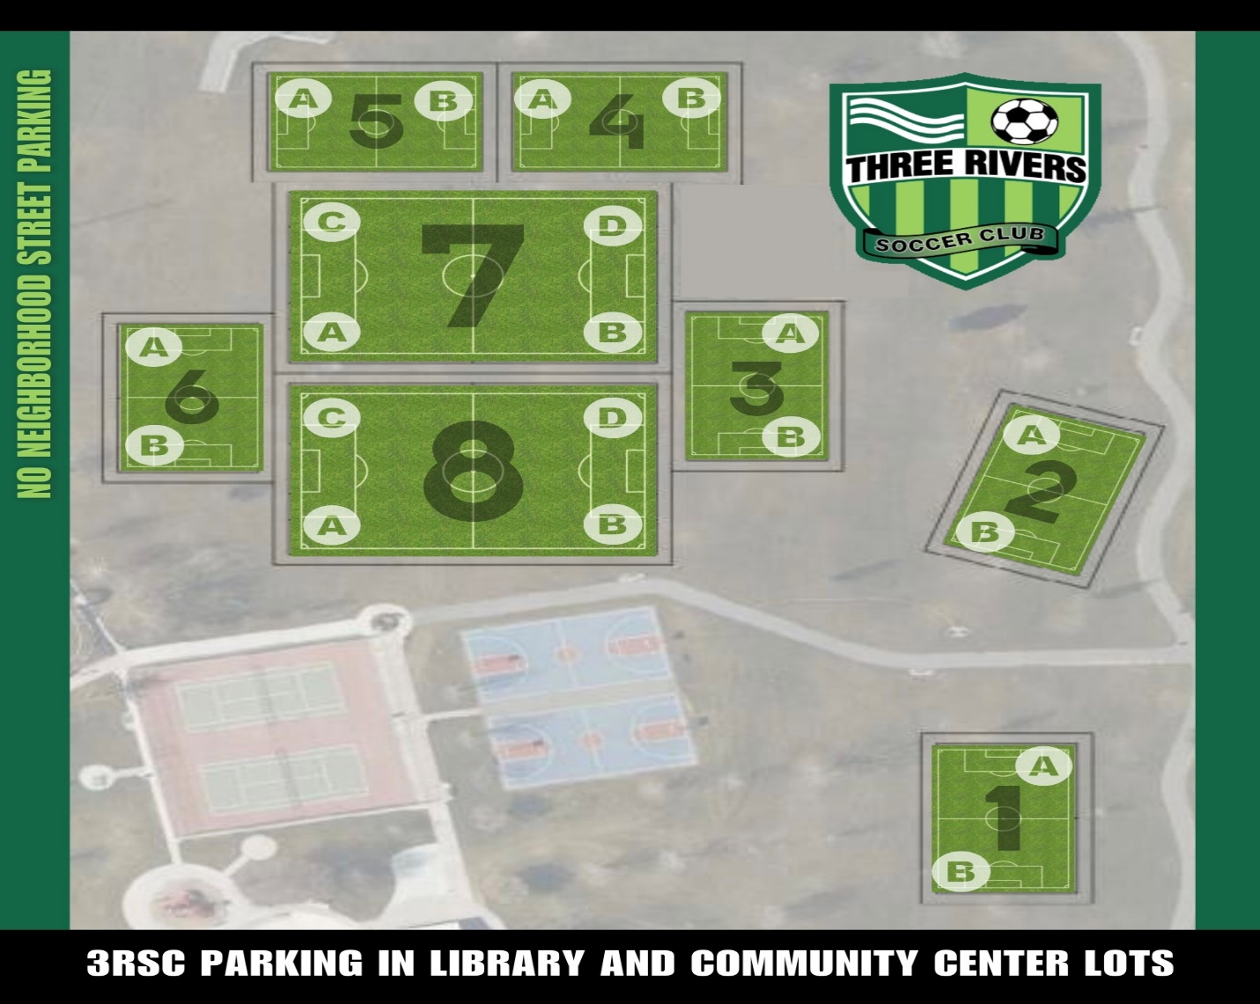

BOYS |  | GIRLS
TEAM | FIELD | TEAM | FIELD
BU7 BULLDOGS (C. ELFERING) | 6A | GU7 EXPRESS (GREENOUGH) | 8D
BU7 TITANS (D. ELFERING) | 6B | GU7 GATORS (CAMPBELL) | 4A
BU7 FLYERS (M. PLUNKETT) | 7C | GU7 RAVENS (TOGIAI) | 4B
BU8 BANDITS (S. HESS) | 3A | GU8 FREEZE (C. CHAVEZ) | 5
BU8 WARRIORS (S. AMEZCUA) | 3B | GU8 CHELSEA (S. MCDAID) | 7D
BU8 PIRATES (HAILEY & MAITE) | 7A | GU8 PISTONS (MIDILI) | 7B
 |  | GU8 THORNS (GRACE & AMY) | 8C

