Week #1
Warm-up:
Dynamic Stretching for Soccer Games and Practice
Frankenstein’s. Stand on the end line, hold your arms straight out in front of you and stiff leg kick as if to kick your opposite palm.
Butt-Kicks.High-Knees/Knee Hugs
Closed-Knees
Open-Knees
Front-to-Back Hip/Leg Swing
Lateral Hip Swing
Forward, Backward Arm Circles.

Dribbling:
Dribbling race, on the coaches’ signal, one player from each line must dribble their soccer ball 5 yards to the cone in front, stopping their soccer ball and dribbling the other ball back to the cone they started at, those players must then run and compete for the ball 20 yards from goal and attempting to score. The next two players can then begin.
- Controlled dribbling will be beneficial than trying to move too fast, especially at the start of this drill

- Start with both feet, if player is to advance, only use right/left foot only to the cone and back.

30mins Scrimmage
Week #2 Practice

Warm-up:

Dynamic Stretching for Soccer Games and Practice
Frankenstein’s. Stand on the end line, hold your arms straight out in front of you and stiff leg kick as if to kick your opposite palm.
Butt-Kicks.High-Knees/Knee Hugs
Closed-Knees
Open-Knees
Front-to-Back Hip/Leg Swing
Lateral Hip Swing
Forward, Backward Arm Circles.

Sharks and Minnows

· This drill can be used to focus on the player using their body to protect the ball by placing their body in between the ball and the defender.

· Build a grid approximately 20X25 yards. This field should be adjusted based on the skill level and number of players participating.

· Two players are designated the SHARK start in the middle of the grid without a ball.

· The remaining player starts with a ball on one of the end lines.

· The minnows, the players with the ball, attempt to swim from one end line to the other while keeping their ball away from the sharks.
The sharks attempt to gain possession and knock the minnows ball out of the grid. Once this happens, the minnow becomes a shark.
The last minnow standing wins the competition.

(30mins) Scrimmage

Week #3 Practice

Warm-up:
Dynamic Stretching for Soccer Games and Practice
Frankenstein’s. Stand on the end line, hold your arms straight out in front of you and stiff leg kick as if to kick your opposite palm.
Butt-Kicks.High-Knees/Knee Hugs
Closed-Knees
Open-Knees
Front-to-Back Hip/Leg Swing
Lateral Hip Swing
Forward, Backward Arm Circles.

Passing:
- Pass on both sides of the cones. 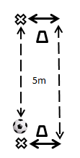
- Recommended equipment: 2 cones, 1 ball
- Number of players required: 2 players
- Set-up: Place two cones five meters apart.
- Exercise: In these soccer passing drills, players pass the ball to each other on either side of two cones in a counter-clockwise direction or clockwise direction.

- Purpose: Soccer passing drills like this one are designed to improve first touch; work on changing direction and creating space.

(30mins) Scrimmage

Week #4 Practice

Warm-up:
Dynamic Stretching for Soccer Games and Practice
Frankenstein’s. Stand on the end line, hold your arms straight out in front of you and stiff leg kick as if to kick your opposite palm.
Butt-Kicks.High-Knees/Knee Hugs
Closed-Knees
Open-Knees
Front-to-Back Hip/Leg Swing
Lateral Hip Swing
Forward, Backward Arm Circles.

Check In, Check Out
- Recommended equipment: 3 cones, 1 ball 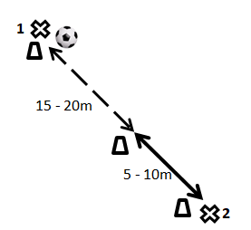
- Number of players required: 2 players
- Set-up: Place two cones 15-20 meters apart and a third cone 5-10 meters from the second cone to form a straight line of three cones.
- Exercise: In these soccer passing drills, player 2 starts at the furthest cone from player 1. Player 2 runs to the center cone and asks for the ball. As player 2 approaches the center cone, player 1 passes them the ball. Player 2 one-touches or two-touches the ball back to player 1 and returns back to their original position to repeat the exercise. After a certain amount of time, switch places.
- Purpose: Soccer passing drills like this one are designed to improve first touch, ability to create space, lose marks, and improve communication.

(30mins) Scrimmage

Week #5 Practice

Warm-up:
Dynamic Stretching for Soccer Games and Practice
Frankenstein’s. Stand on the end line, hold your arms straight out in front of you and stiff leg kick as if to kick your opposite palm.
Butt-Kicks.High-Knees/Knee Hugs
Closed-Knees
Open-Knees
Front-to-Back Hip/Leg Swing
Lateral Hip Swing
Forward, Backward Arm Circles.

Short passing to longer passing
- Recommended equipment: 1 ball
- Number of players required: 2 players
- Set-up: Players begin standing 5 meters apart.
- Exercise: Players pass back and forth. Players (or coach) decide how they’d like to pass and receive the passes (one touch, two touches, right foot only, left foot only, etc.). Aim for clean passes and touches. Set a goal (10 without a mistake, 20 without a mistake, 100?) Each time you meet the goal, move back 10 meters.
- Purpose: These soccer passing drills improve first touch, improve accuracy, and concentration.

(30mins) Scrimmage

Week #6 Practice

Warm-up:
Dynamic Stretching for Soccer Games and Practice
Frankenstein’s. Stand on the end line, hold your arms straight out in front of you and stiff leg kick as if to kick your opposite palm.
Butt-Kicks.High-Knees/Knee Hugs
Closed-Knees
Open-Knees
Front-to-Back Hip/Leg Swing
Lateral Hip Swing
Forward, Backward Arm Circles.

Passing through gates
- Recommended equipment: 1 ball, 10 or more cones. 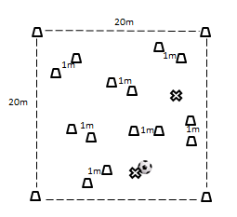
- Number of players required: 2 players
- Set-up: Set up a 20m x 20m playing space (placing a cone at each corner if desired). Within the playing space, set up 5-8 gates with cones 1m apart evenly scattered throughout the 20m space.
- Exercise: During these soccer passing drills, players practice dribbling around the 20m space passing through the gates.
- Purpose: Practice passing at angles; improve first touch, accuracy and concentration

(30mins) Scrimmage

Week #7 Practice
Warm-up:
Dynamic Stretching for Soccer Games and Practice
Frankenstein’s. Stand on the end line, hold your arms straight out in front of you and stiff leg kick as if to kick your opposite palm.
Butt-Kicks.High-Knees/Knee Hugs
Closed-Knees
Open-Knees
Front-to-Back Hip/Leg Swing
Lateral Hip Swing
Forward, Backward Arm Circles.

1v1 controlled scoring
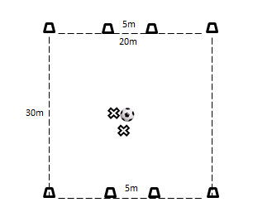
- Recommended equipment: 1 ball, 8 cones
- Number of players required: 2 players
- Set-up: Set up a 30m by 20m pitch using cones to mark the corners. Make two 5m goals at each end line.
- Exercise: Players start in the middle of the pitch. (Decide who starts with the ball). Players can only score by stopping the ball on the imaginary line between the goal cones. After a player scores, the other player starts with the ball from their own end line (where the other player scored).
- Purpose: With this soccer dribbling drill, practice dribbling with speed and control; practice 1v1 offense and defense; improve physical fitness.

(30mins) Scrimmage

Week #8 Practice

Warm-up:
Dynamic Stretching for Soccer Games and Practice
Frankenstein’s. Stand on the end line, hold your arms straight out in front of you and stiff leg kick as if to kick your opposite palm.
Butt-Kicks.High-Knees/Knee Hugs
Closed-Knees
Open-Knees
Front-to-Back Hip/Leg Swing
Lateral Hip Swing
Forward, Backward Arm Circles.

Coaches choice for practice plans!!!!!

